**Lab-6: Install and Configure Print Server on Windows Server 2019**

**Lab Objectives**

* Install and configure a Print Server on Windows Server 2019.
* Configure and manage network printers.
* Assign users and organizational units.
* Capture and document each configuration step.

**Lab Topology**

**Machine Number Host Name Role RAM Domain/IP**

1. IT2-DC01 AD DS, DNS, DHCP 2 GB NORTHERNCOLLEGE.LOCAL
2. IT2-PNR01 Print Server 2 GB NORTHERNCOLLEGE.LOCAL
3. Win10-CL01 Client Machine 2 GB Auto/DHCP
4. Win11-CL02 Client Machine 2 GB Auto/DHCP

**Lab Tasks and Required Screenshots**

1. **Hardware Configuration Verification (5 points)** 
   * Take a screenshot of the hardware configuration for all four machines. *(Screenshot 1)* 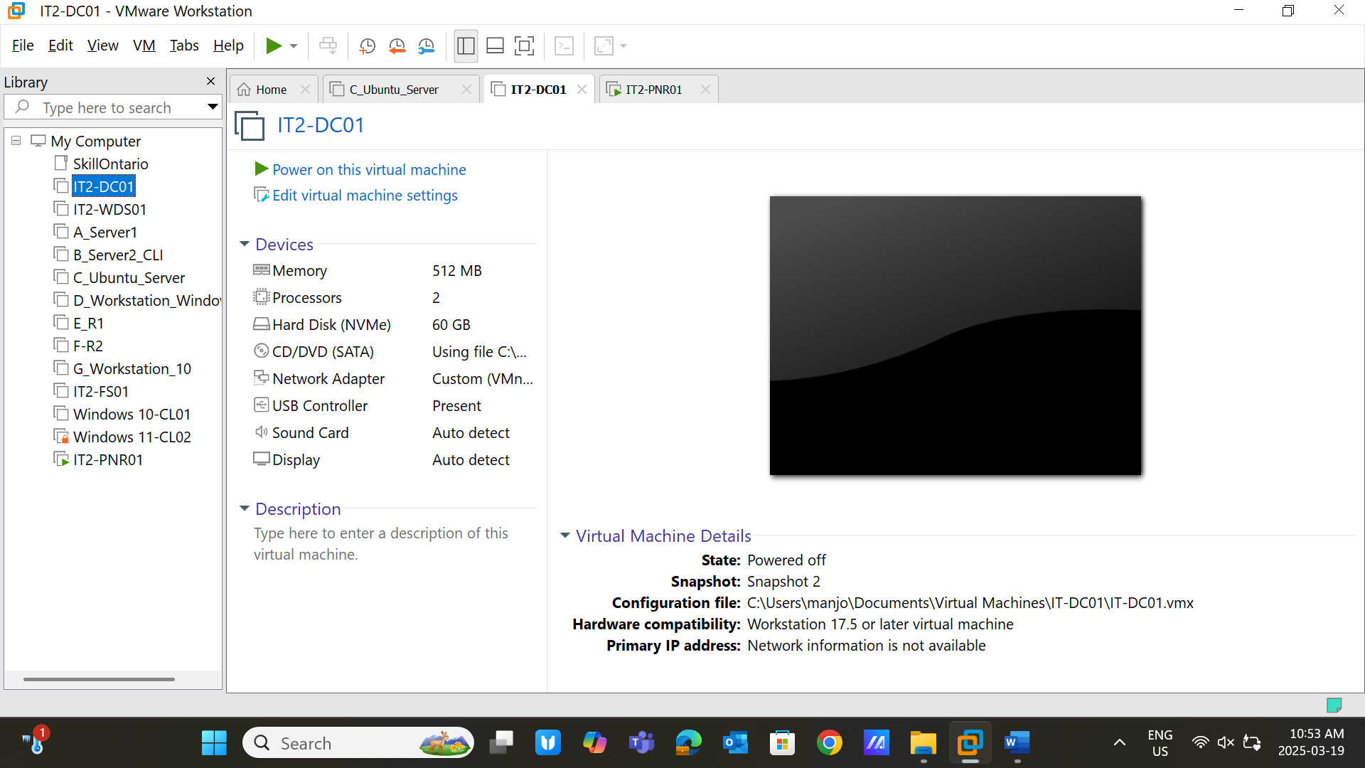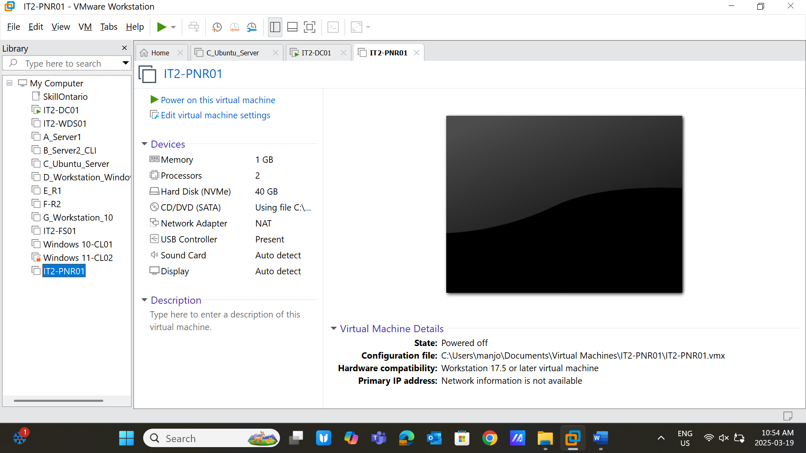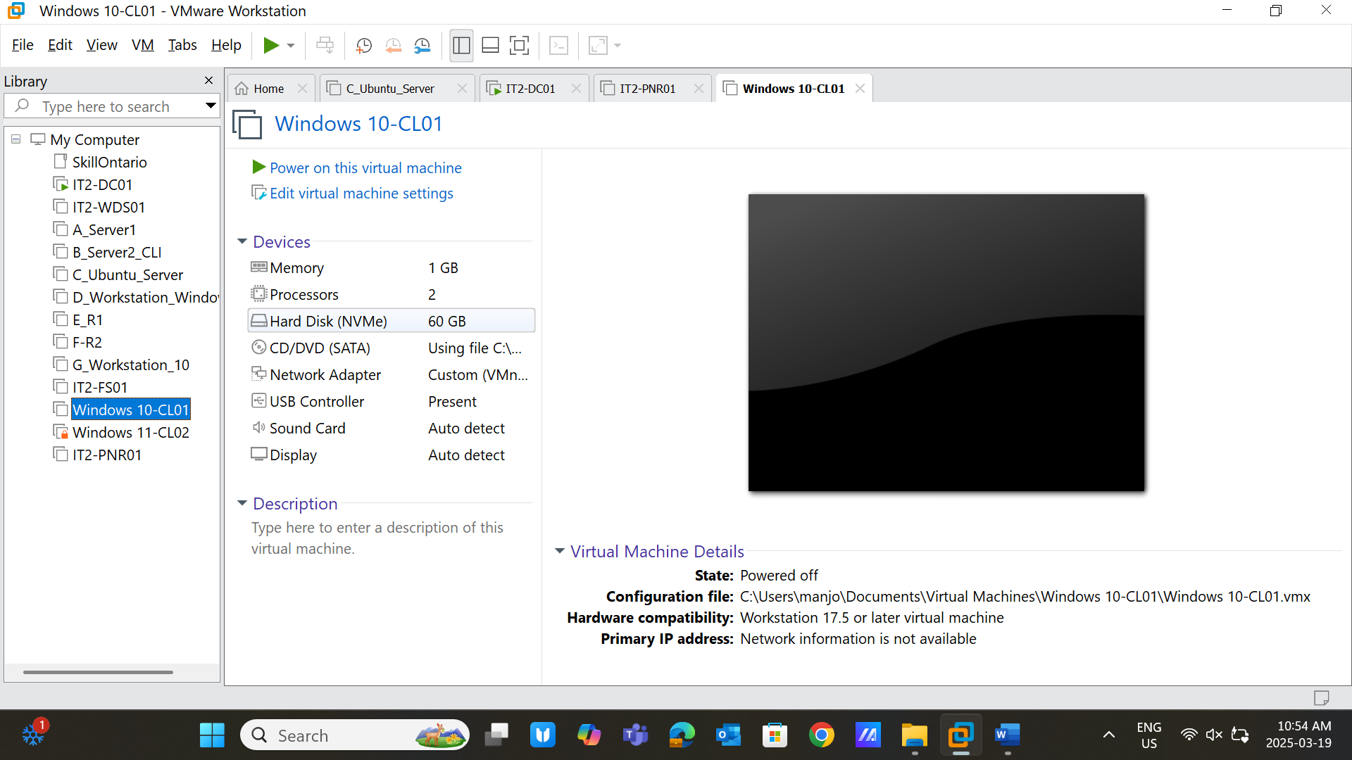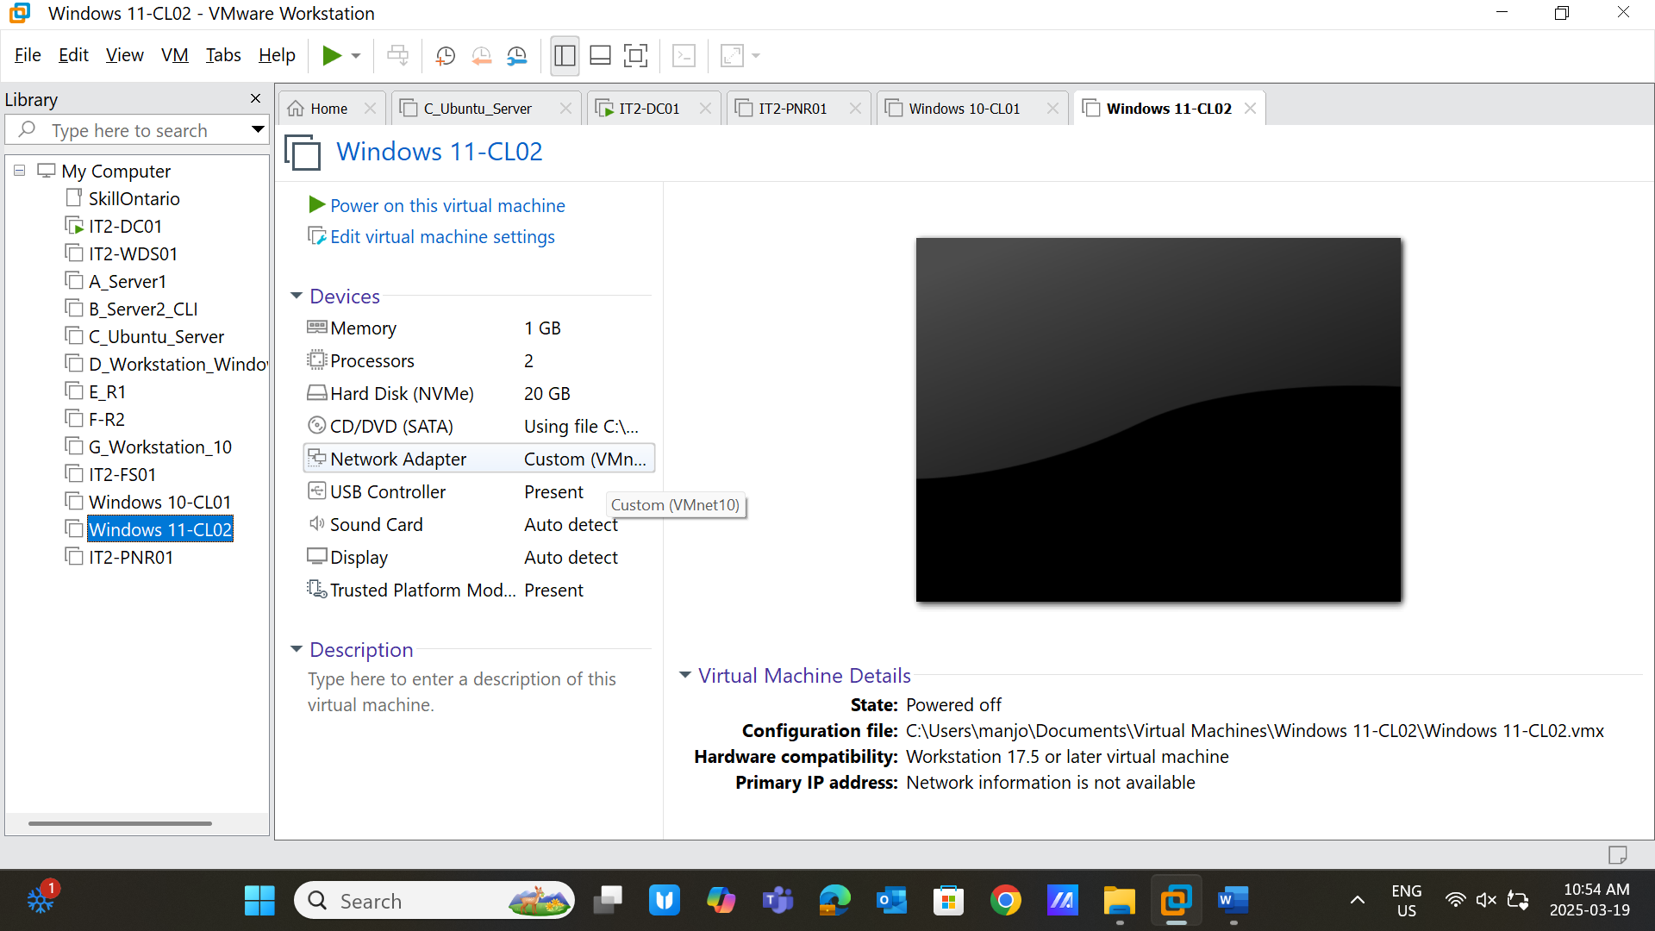
2. **User Account Creation (5 points)** 
   * Create two users:
     + User03: Password@123 o User04: Password@123
   * Take a screenshot of the created users. *(Screenshot 2)* 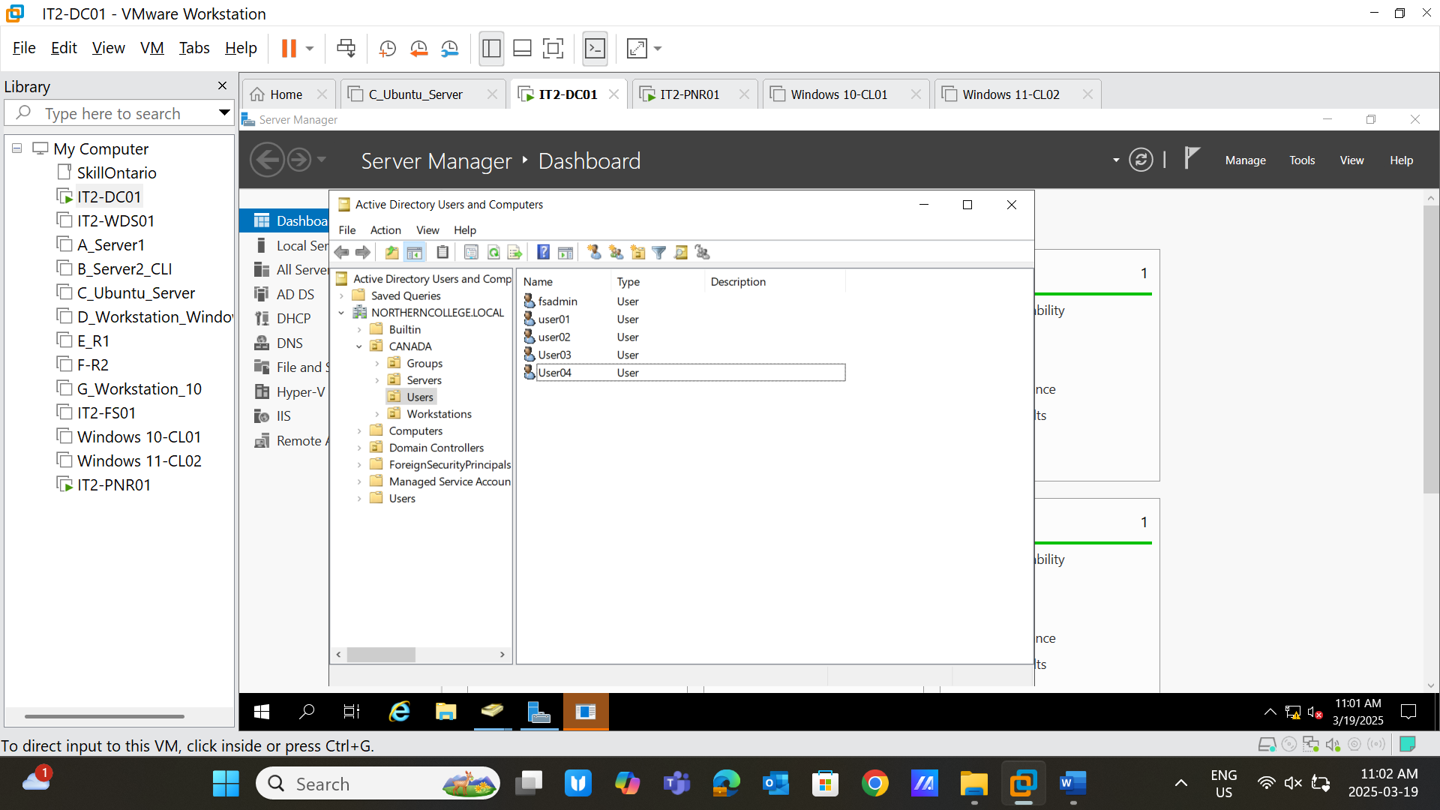
3. **User Login Verification (5 points)** 
   * Log in with User03 on Windows 10 and User04 on Windows 11.
   * Take a screenshot of the output from the whoami command. *(Screenshot 3)* 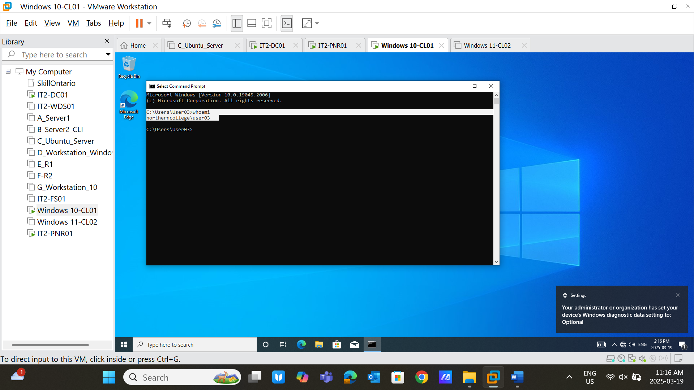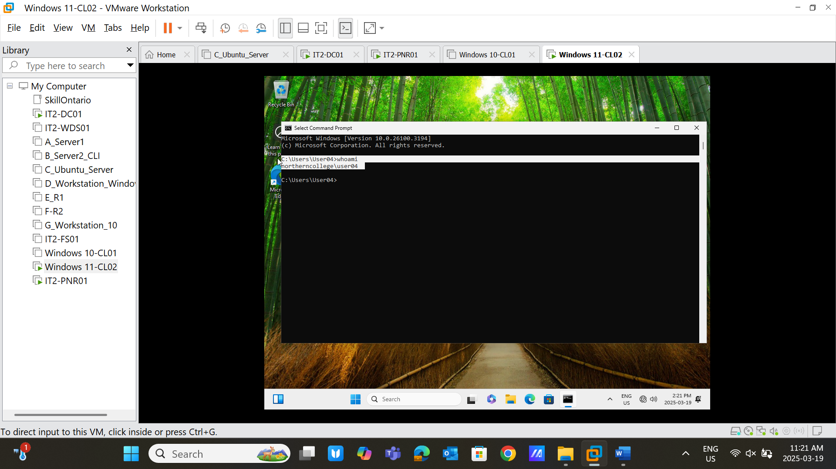
4. **Organizational Unit (OU) Assignment (5 points)** 
   * Move:
     + Windows 10 and 11 clients to **OU -> Canada -> Workstations** o IT2-PNR01 to **OU -> Canada -> Servers**
   * Take a screenshot showing the assignments. *(Screenshot 4)* 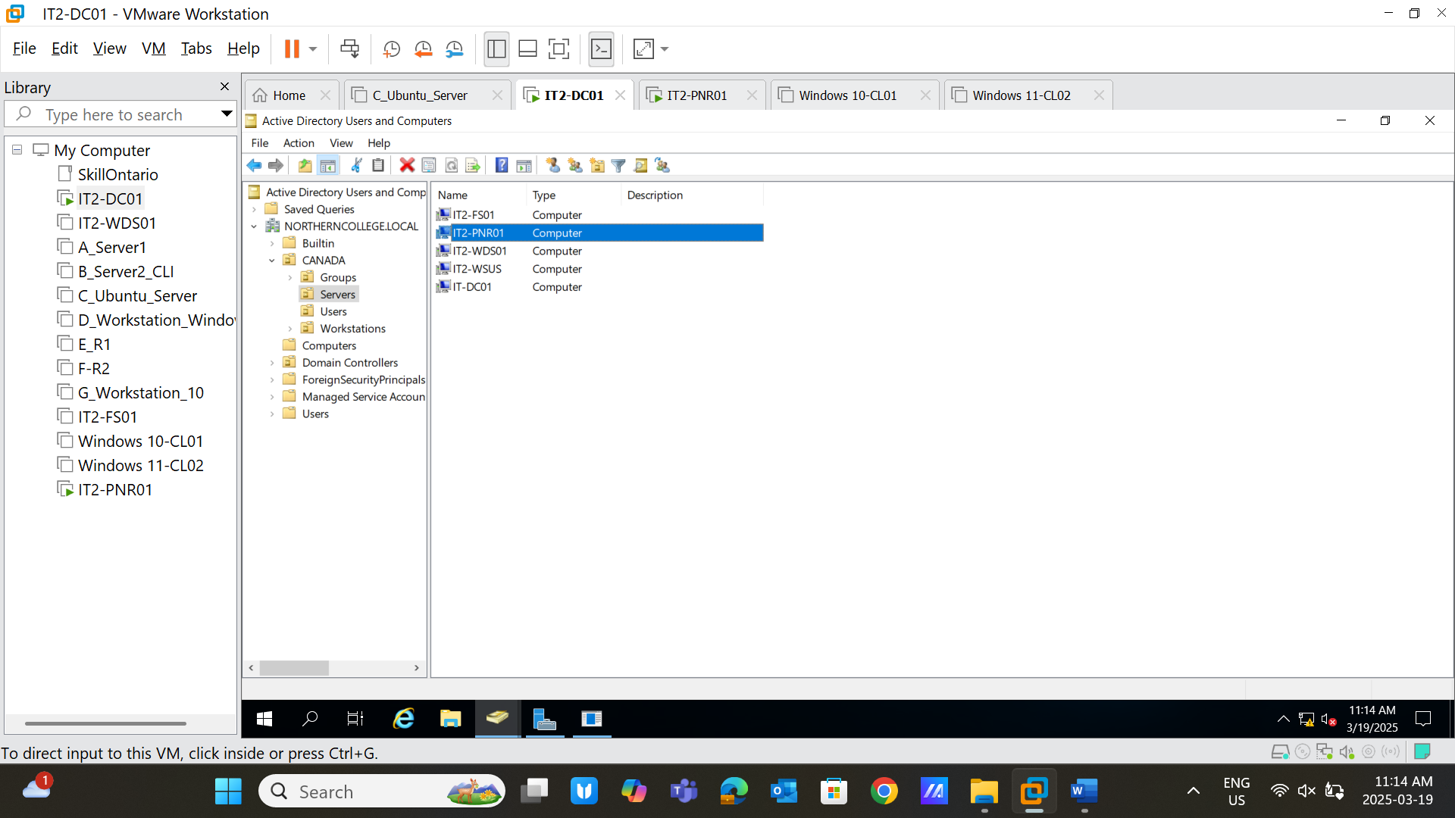
5. **IT2-PNR01 Basic Configuration (5 points)** 
   * Configure IT2-PNR01:
     1. IPv4 settings
     2. Disable Internet Explorer Enhanced Security Configuration
     3. Rename machine to **IT2-PNR01**
     4. Add machine to **NORTHERNCOLLEGE.LOCAL**
   * Take a screenshot of these settings. *(Screenshot 5)* 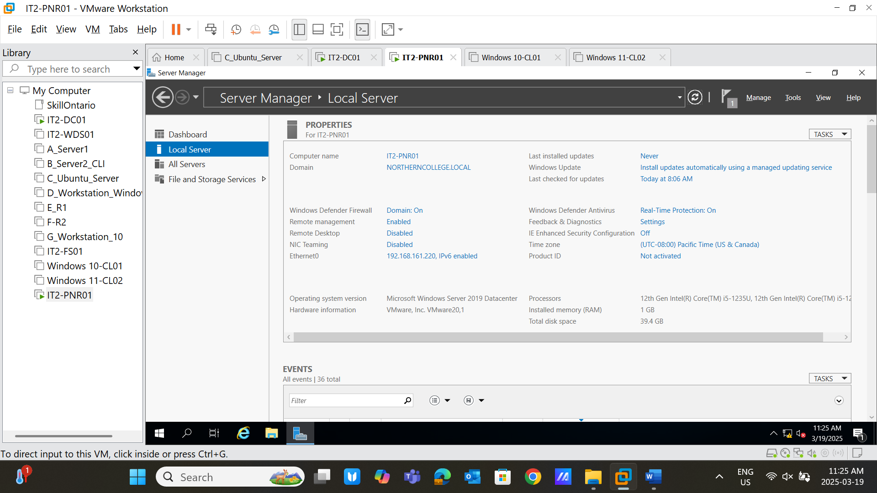
6. **Install Print and Document Services (5 points)** • Install the **Print and Document Services** role.
   * Take a screenshot of the successful installation page. *(Screenshot 9)* 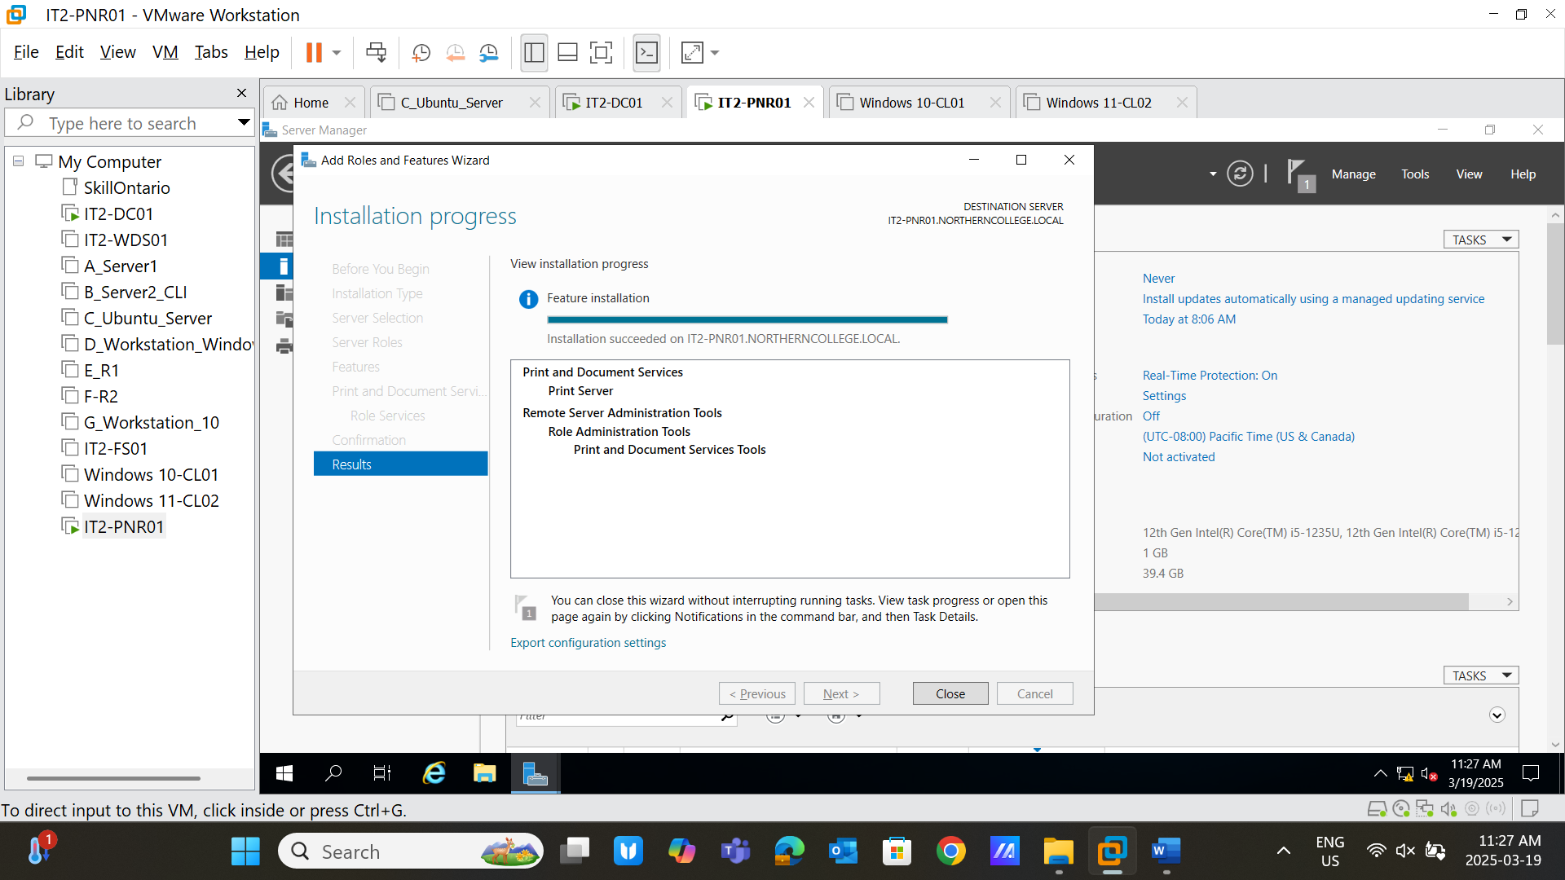
7. **Configure Printer 1 (Canon) (5 points)** 
   * Create a **TCP/IP port** inside **Print Management** on IT2-PNR01.
   * Assign an available **IPv4 address**.
   * Take a screenshot of the configuration. *(Screenshot 10)* 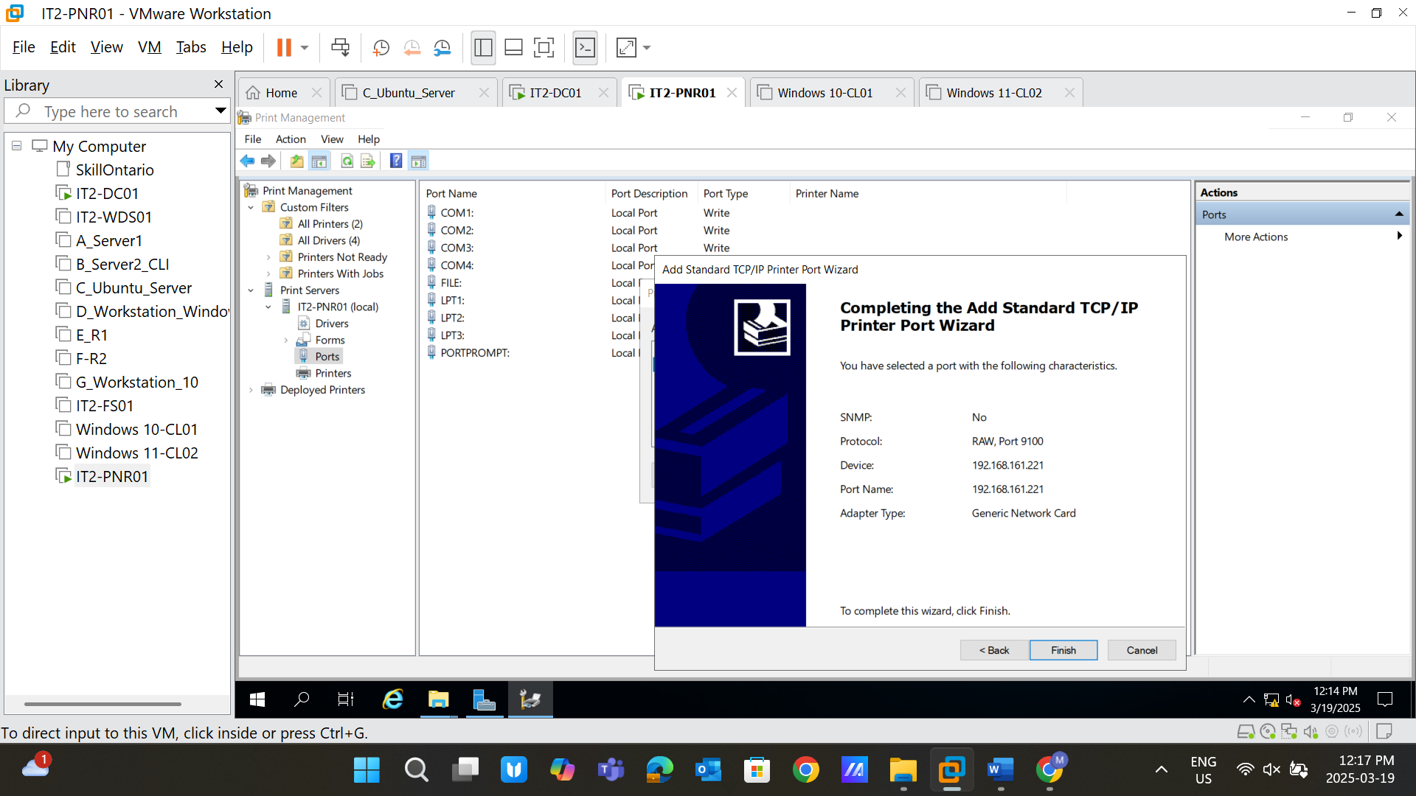
8. **Install Printer Drivers (5 points)** 
   * Install drivers for **HP and Canon** printers.
   * Take a screenshot of the completed installation. *(Screenshot 11)* 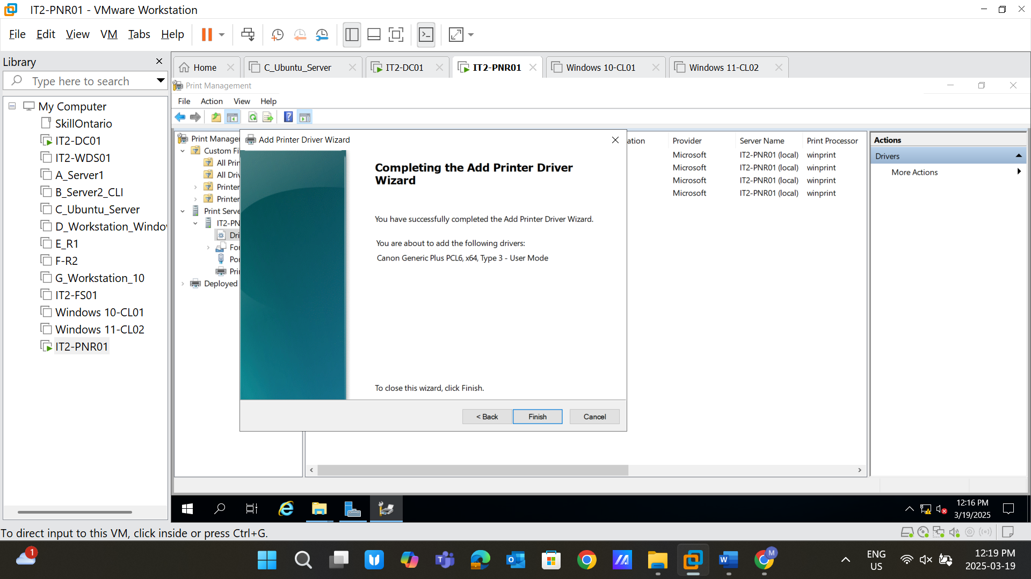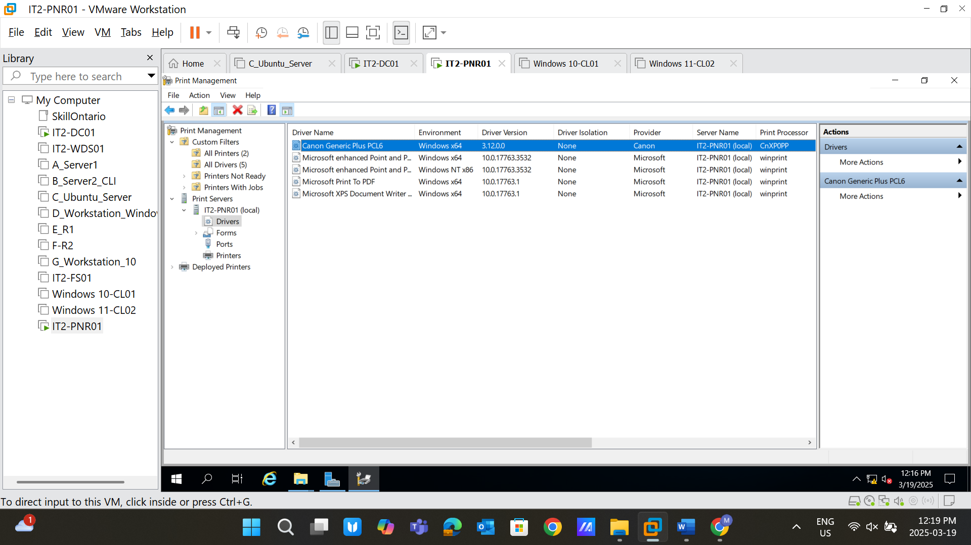
9. **Configure Printer Ports (5 points)** 
   * Configure **TCP/IP printer port wizard**:
     + **Device Type**: Generic Network Card
   * Take a screenshot of the completed configuration. *(Screenshot 12 & Screenshot 13)* 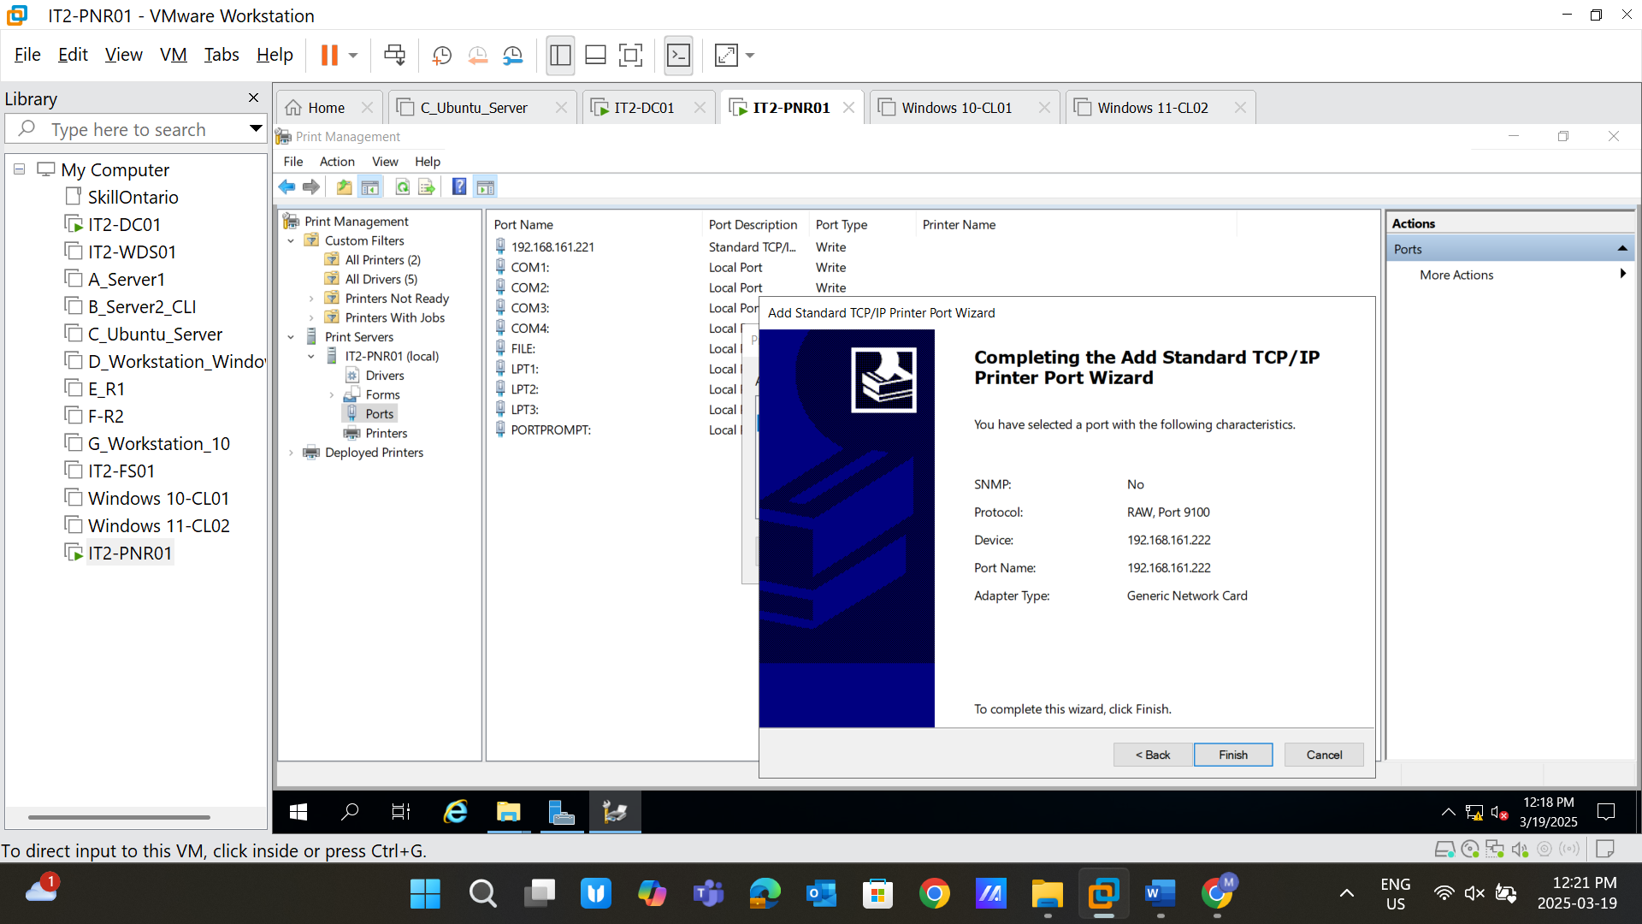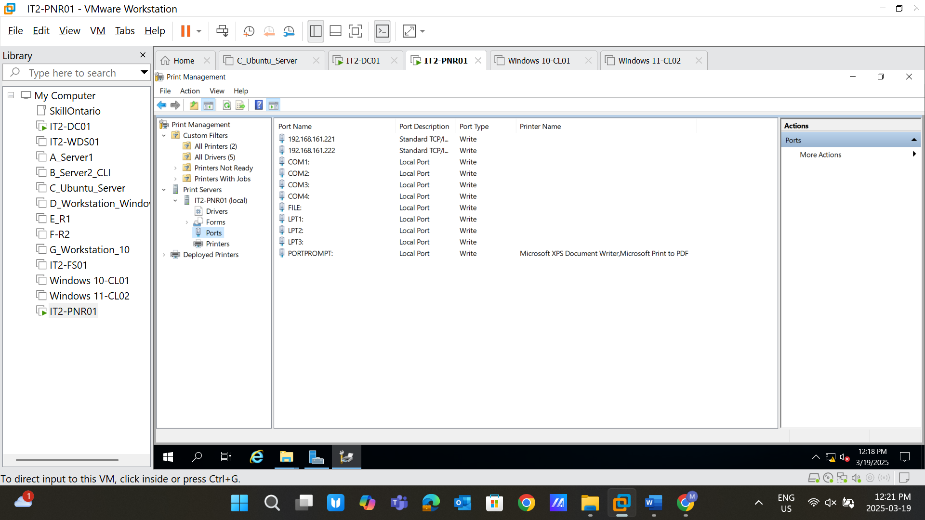
10. **Add Printer Drivers (5 points)** 
    * Use **Add Printer Driver Wizard**.
    * Select the correct driver folder and choose the **Setup Information** file.
    * Take a screenshot for both **HP and Canon** installations. *(Screenshot 14)* 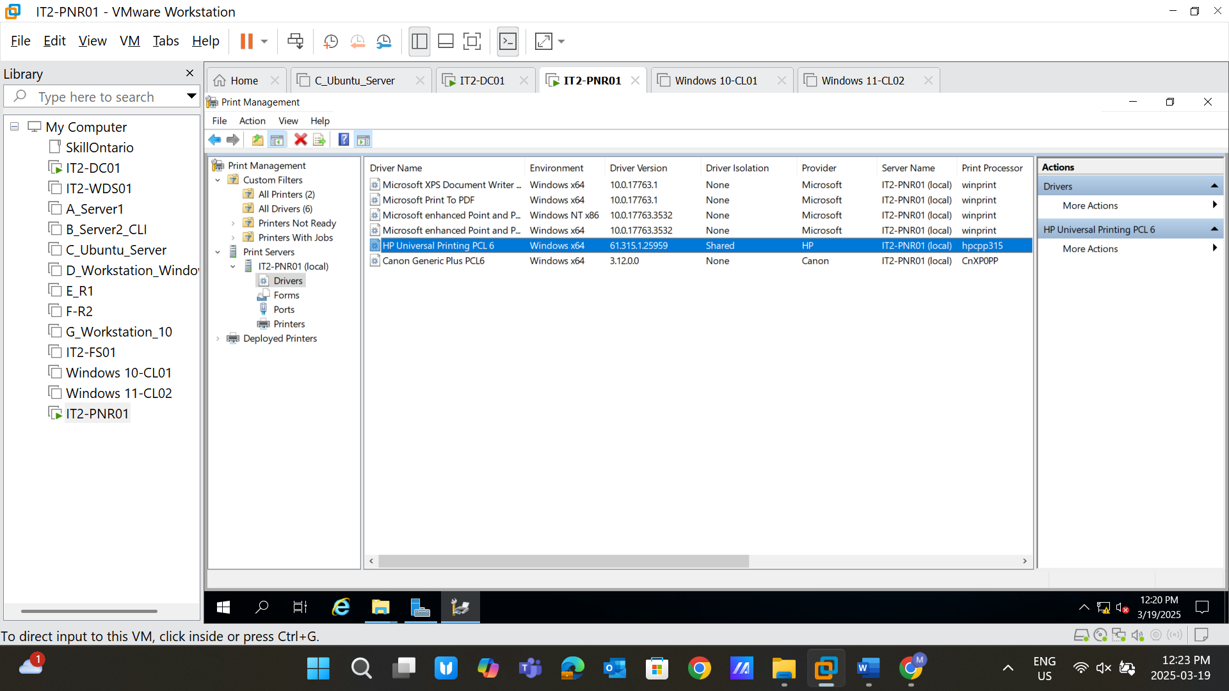
11. **Add Printers (5 points)** 
    * **Canon Printer:**
      + Select **First TCP/IP Port** o Printer Name: **Canon - CISCO Lab** o Share Name: **Canon - CISCO Lab** o Location: **Northern College - Timmins Campus** o Comment: **This is a shared black and white printer** 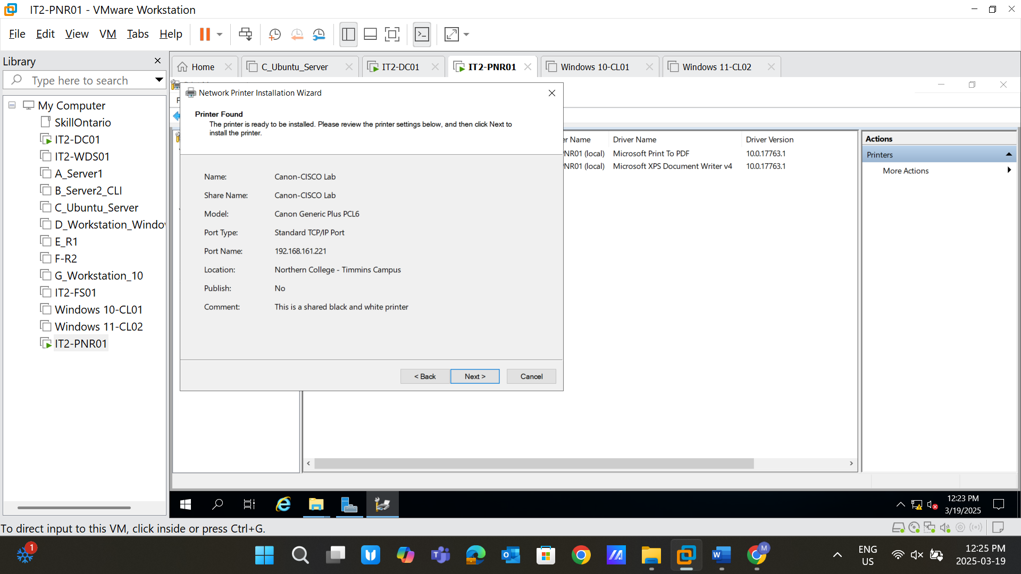
    * **HP Printer:**
      + Select **First TCP/IP Port** o Printer Name: **Canon - HR Office** o Share Name: **Canon - HR Office** o Location: **Northern College - Timmins Campus** o Comment: **This is a shared black and white printer** 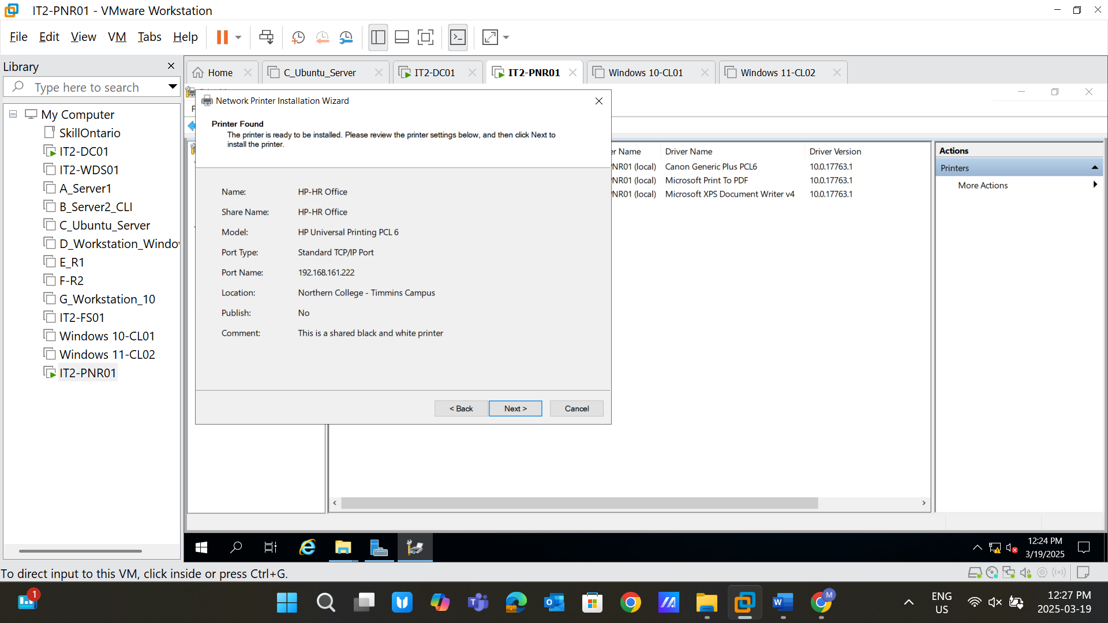
    * Take a screenshot for each added printer. *(Screenshot 15)* 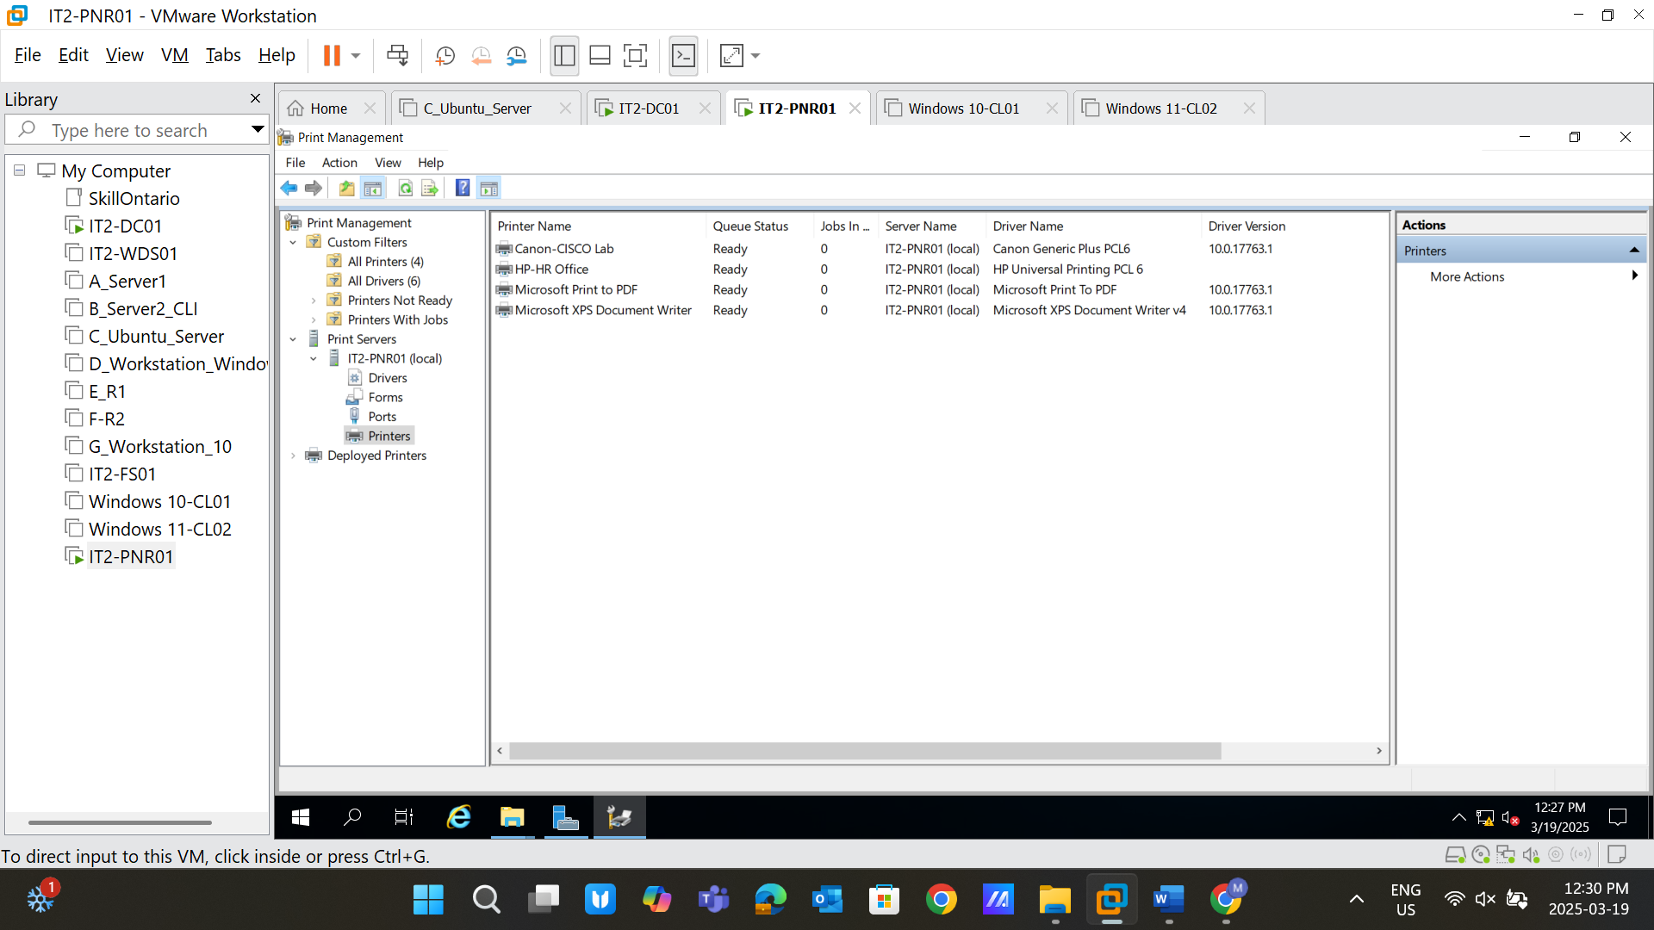
12. **Client Printer Installation (5 points)** 
    * Install both printers on **Windows 10** and **Windows 11** clients.
    * Take a screenshot of the successful installation. *(Screenshot 16)* 